Creating a Public Amazon S3 Bucket

Objectives
- Create a bucket in Amazon S3
- Add an object to a bucket
- Manage access permissions on an object and a bucket
- Create a bucket policy
- Use bucket versioning

Step 1: Navigate to Amazon S3 Landing Page
- Open the AWS Management Console and navigate to the Amazon S3 service. The landing page presents the S3 service
- Click the "Create bucket" button to begin the bucket creation

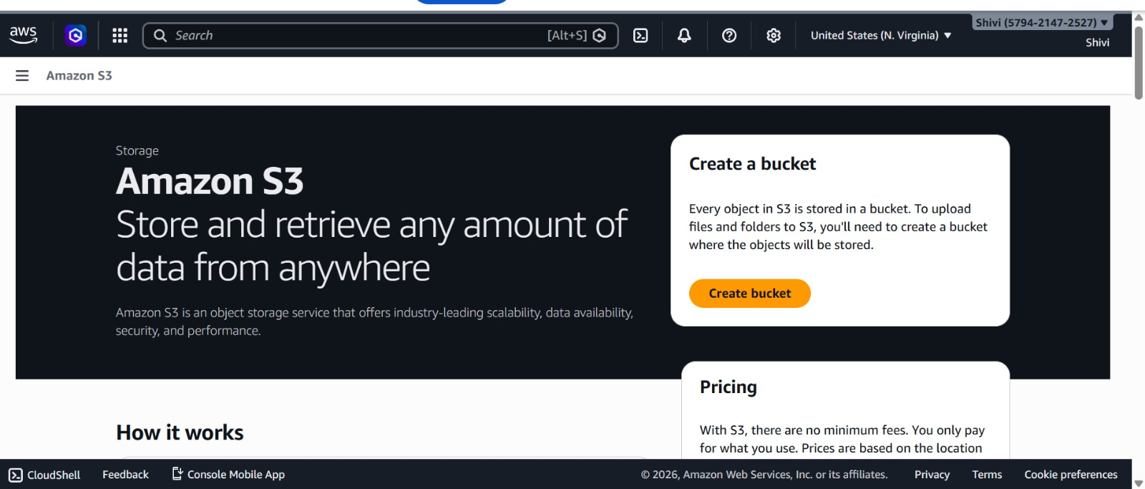

Step 2: Configure Bucket Name and Namespace settings
Configure the bucket type, namespace, and a unique name:

Bucket Type
- General Purpose — Selected.
- Global namespace — Selected

Bucket Name
- Bucket name entered: shivi-2323. Must be 3–63 characters, lowercase, using letters, numbers, hyphens, or periods.
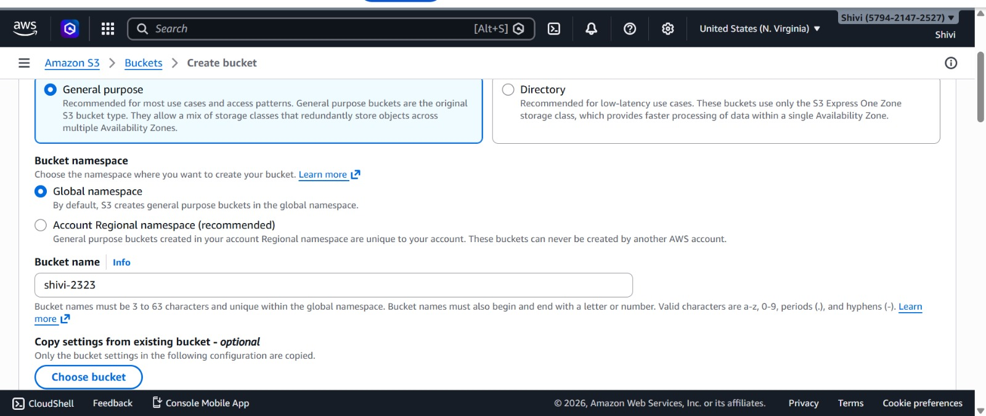

Step 3: Configure Object Ownership (ACLs)
Under Object Ownership, configure who controls access to objects in this bucket:
- ACLs enabled — Selected
- Object writer — Selected

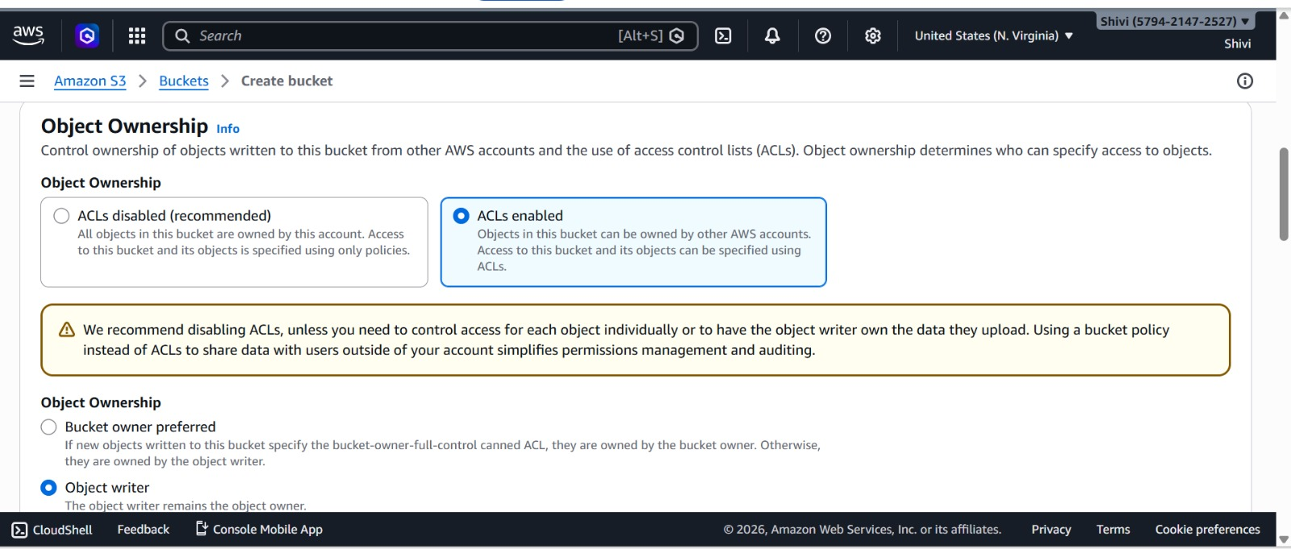

Step 4: Configure Block Public Access Settings
To allow public access to the bucket, uncheck all four Block Public Access options:
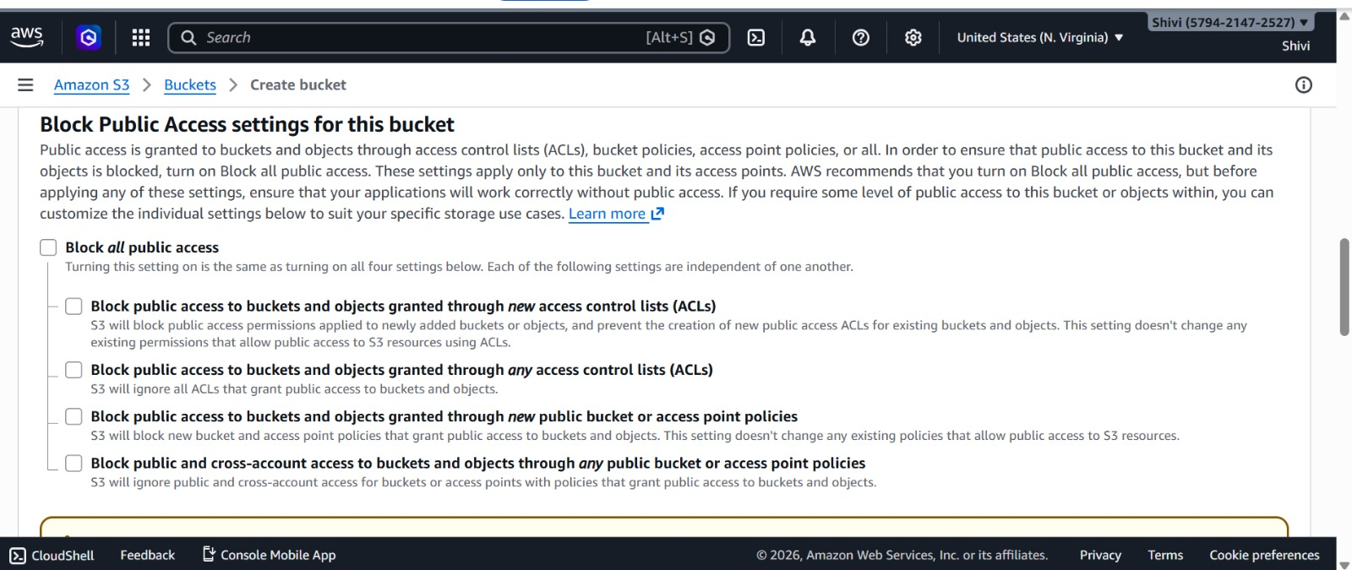

Step 5: Set Default Encryption
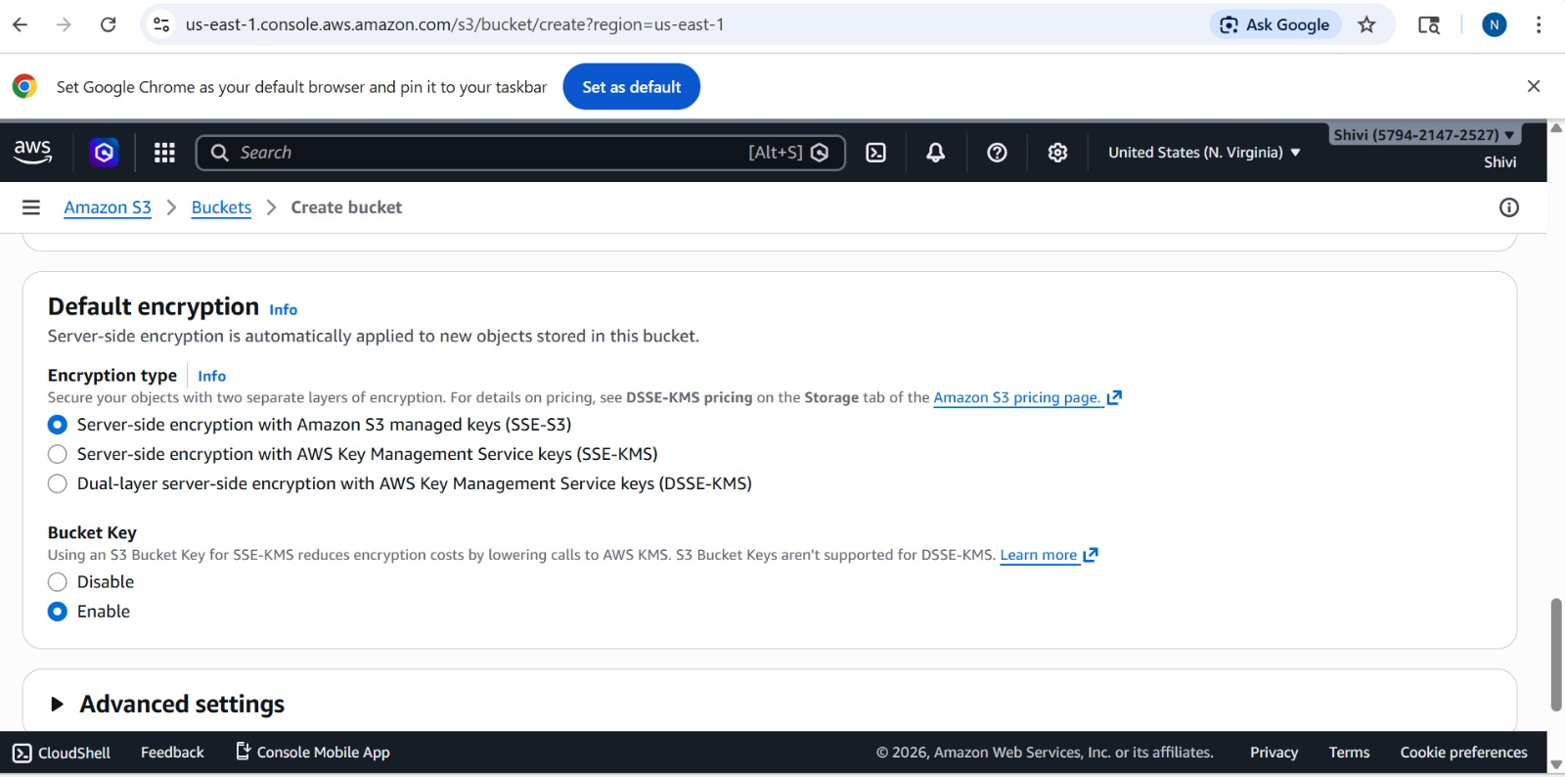

Step 6: View object uploading and bucket creation
Navigate back to the bucket to confirm the upload was successful. The Objects tab shows:
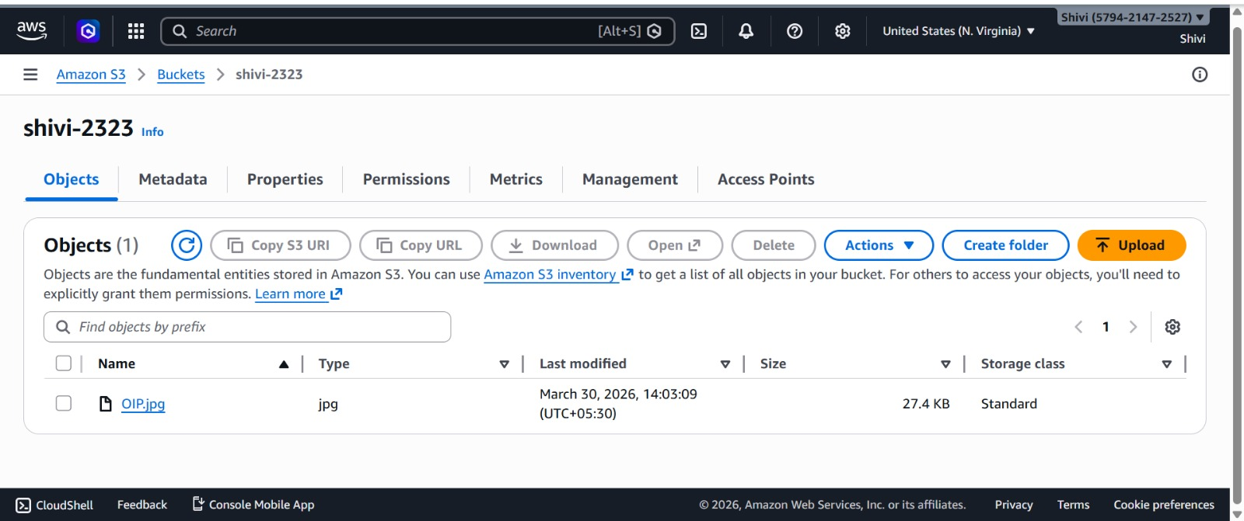

Step 7: Make public using ACL. Making the object public

